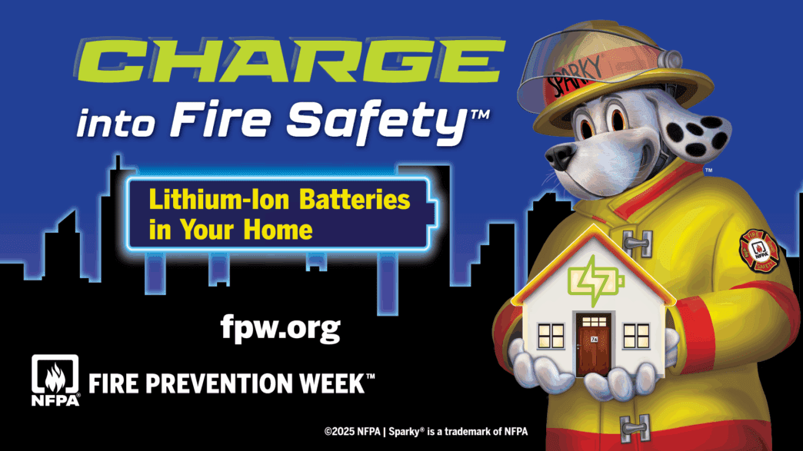

2025 New Jersey Fire Prevention Poster Contest:
https://www.nj.gov/dca/dfs/

NFPA Link for Lithium-Ion Battery Guidance Material:
https://www.nfpa.org/events/fire-prevention-week

Lithium-Ion Battery Fire Safety: 3 Steps
Buy only listed products. When buying a product that uses a lithium-ion battery look for a safety certification mark such as UL, ETL, or CSA. This means it meets important safety standards.
Charge devices safely. Always use the cords that came with the product to charge. Follow the instructions from the manufacturer. Buy new chargers from the manufacturer or one that the manufacturer has approved. Charge your device on a hard surface. Don’t overcharge your device. Unplug it or remove the battery when it’s fully charged.
Recycle batteries responsibly. Don’t throw lithium-ion batteries in the trash or regular recycling bins because they could start a fire. Recycle your device or battery at a safe battery recycling location. Visit call2recycle.org to find a recycling spot near you.

